**Ryley School** 

**The Small School With A Big**



Annual Education Results Report

2023-24

September 2024

**Table of Contents**

**Annual Education Result Review 2023-2024**

Alberta Education Assurance Measures

Accountability Statement

Whistleblower Protection

School Profile

Alberta Education Assurance Measures- Overall Summary

Priorities & Results

Priority 1: Literacy & Numeracy

Priority 2: High Quality Teaching & Optimum Learning

Priority 3: Equity

Attendance

School Budget Summary

School Year Summary

Stakeholder Engagement

**Education Plan 2024-2025**

Learning Success For All

Enhance High Quality Learning & Working Environments

Well Being

# 

### 

##### Alberta Education Assurance Measures

**What is Assurance?**

The Alberta Education Assurance Framework is one way that the Alberta Government ensures that our education system is working. Each spring school divisions and their schools create education plans that guide us throughout the year as we work to teach your students and to keep current with educational research, manage resources effectively and ensure our schools are excellent places to grow up. You may have completed a survey in the early part of the year where you provided feedback on how our schools were doing. You may also have had students write, or have heard of, our Provincial Achievement Tests or Diploma Exams. These are just a few of the examples of how schools and divisions collect data to let us know how we are progressing.

In the fall schools and divisions are provided with the results of our hard work in the form of an Annual Education Results Report. This is that report.

**What is measured?**

As you look through this report you will see that there are many different measures including exam results, high school completion rates, Safe and Caring measures, data specific to our First Nations, Metis and Inuit students and our English Language Learners. Financial information is also reported on in this document.

**What is “local data”?**

Local data is evidence collected by schools and by divisions and used, along with our Alberta Education data, to paint a fuller picture of what is happening in our school. This includes things like results from testing students' reading, or mathematics skills, surveys from schools that ask questions specifically about our school.

##### 

##### 2023-2024 Accountability Statement

##### 

##### 

##### Whistleblower Protection

##### Whistleblower Protection Whistleblower Protection: Section 32 of the Public Interest Disclosure Act (2013) requires that school authorities include their annual report of disclosures in their AERR. For a copy of the legislation or for further information and resources, please visit the Public Interest Commissioner’s website at www.yourvoiceprotected.ca

##### 

##### Accountability Statement

##### The *Ryley School* *Annual Education Results Report* for the 2023-2024 school year was prepared under the direction of the Board of Trustees in accordance with the responsibilities under the Education Act and the Fiscal Planning and Transparency Act. The Board is committed to using the results in this report, to the best of its abilities, to improve outcomes for students and to ensure that all students in the school authority can acquire the knowledge, skills and attitudes they need to be successful and contributing members of society. This *Annual Education Results Report* for 2023-2024 was approved by our School Council.

##### 

Selina Hellekson November 29, 2024 Maria Schaade November 29, 2024

Parent Council Chair Date Principal Date

##### 

##### 

##### 

##### 

##### 

| **Ryley School Profile** |
| --- |
| Ryley School is situated 80 km east of Edmonton along Highway 14 in the village of Ryley, proudly serving the families of Ryley, Holden, and the surrounding areas. Our school enrolls approximately 105 students from Kindergarten to Grade 9. We are dedicated to nurturing strong relationships within our school community and greatly value the ongoing support we receive from families, community members, and local businesses each year. This collaboration allows us to cultivate a truly professional learning environment.  At Ryley School, we take pride in providing an inclusive and accessible educational experience. There are no school fees, and all necessary supplies are provided to each student at the beginning of the year. Additionally, students have the opportunity to engage in a wide array of extra and co-curricular activities at no cost to parents, thanks to our annual grant from Clean Harbors. We also offer a complimentary breakfast and lunch program to ensure that all students are nourished and ready to learn.  Our focus at Ryley School is on educating the whole student. We emphasize early literacy and numeracy interventions, prioritize student wellness, and implement Effective Behavior Supports, including our Behavior Matrix. This comprehensive approach fosters a safe and nurturing environment where students can thrive academically. Our dedicated and compassionate staff firmly believe that, with the right encouragement and support, every student has the potential to succeed. |
| **Our Vision:** Every Student, Every Day, A Success |
| **Our Mission:** At Ryley School, our mission is to celebrate the unique strengths of every individual, foster a safe and nurturing environment for growth, and cultivate strong partnerships between the school, home, and community. |

## 

## 

## Alberta Education Assurance Measures - Overall Summary

**Ryley School**

|  |  |  |  |  |  |  |  |  |  |  |  |
| --- | --- | --- | --- | --- | --- | --- | --- | --- | --- | --- | --- |
| **Assurance Domain** | **Measure** | **Ryley School** | | | **Alberta** | | | **Measure Evaluation** | | | |
| **Current Result** | **Prev Year Result** | **Prev 3 Year Average** | **Current Result** | **Prev Year Result** | **Prev 3 Year Average** | **Achievement** | **Improvement** | | **Overall** |
| Student Growth and Achievement | Student Learning Engagement | **92.5** | 85.5 | 83.3 | **83.7** | 84.4 | 84.8 | n/a | Improved | | n/a |
| Citizenship | **77.9** | 87.8 | 86.2 | **79.4** | 80.3 | 80.9 | High | Declined | | Acceptable |
| 3-year High School Completion | **n/a** | * | 88.7 | **80.4** | 80.7 | 82.4 | n/a | n/a | | n/a |
| 5-year High School Completion | **81.8** | 94.1 | 86.1 | **88.1** | 88.6 | 87.3 | Intermediate | Maintained | | Acceptable |
| PAT6: Acceptable | **n/a** | 54.5 | 54.5 | **n/a** | 66.2 | 66.2 | n/a | n/a | | n/a |
| PAT6: Excellence | **n/a** | 27.3 | 27.3 | **n/a** | 18.0 | 18.0 | n/a | n/a | | n/a |
| PAT9: Acceptable | **n/a** | * | n/a | **n/a** | 62.6 | 62.6 | n/a | n/a | | n/a |
| PAT9: Excellence | **n/a** | * | n/a | **n/a** | 15.5 | 15.5 | n/a | n/a | | n/a |
| Diploma: Acceptable | **n/a** | n/a | n/a | **n/a** | 80.3 | 80.3 | n/a | n/a | | n/a |
| Diploma: Excellence | **n/a** | n/a | n/a | **n/a** | 21.2 | 21.2 | n/a | n/a | | n/a |
| Teaching & Leading | Education Quality | **93.3** | 96.4 | 90.8 | **87.6** | 88.1 | 88.6 | Very High | Maintained | | Excellent |
| Learning Supports | Welcoming, Caring, Respectful and Safe Learning Environments (WCRSLE) | **85.6** | 89.3 | 86.0 | **84.0** | 84.7 | 85.4 | n/a | Maintained | | n/a |
| Access to Supports and Services | **83.0** | 89.3 | 86.3 | **79.9** | 80.6 | 81.1 | n/a | Maintained | | n/a |
| Governance | Parental Involvement | **81.4** | 100.0 | 90.0 | **79.5** | 79.1 | 78.9 | High | Maintained | | Good |
|  |  |  |  |  |  |  |  |  |  |  |  |

| **Priority 1: Literacy and Numeracy** | | | | | |
| --- | --- | --- | --- | --- | --- |
| All students will improve in literacy and numeracy. | | | | | |
| **SCHOOL GOAL(s)**   * To improve number sense for grades 4-9 students, which will be measured by end of year numeracy assessments in June 2024. * To improve fluency and reading comprehension for grades 1-9 students, which will be measured by the end of year literacy assessments in June 2024. | | | | | |
| **Assurance Domains:**  **Student Growth and Achievement**- The ongoing progress of students’ learning, relative to identified provincial learning outcomes that enable them to engage intellectually, grow continuously as learners, and demonstrate citizenship.  **Teaching and Learning**-Teachers and leaders apply appropriate knowledge and abilities to make decisions that demonstrate professional practice standards, which result in quality teaching, leading, and optimum learning for all students | | | | | |

**Numeracy: Elk Island Catholic Schools (EICS) Numeracy Screener**

**(End of Year Results)**

|  | **Grade 1**  **Above 60%** | **Grade 2**  **Above 60%** | **Grade 3**  **Above 60%** |
| --- | --- | --- | --- |
| School | 70% | 54% | 62% |
| BRSD | 99.5% | 92% | 78% |

### 

**Literacy:** [**Castles and Coltheart 3 (CC3) & Letter Name-Sound (LeNS) Test**](https://www.alberta.ca/early-years-assessments#jumplinks-1)

**(End of Year Results)**

|  | **CC3**  **Grade 2 At Risk** | **LeNS**  **Grade 2 At Risk** | **CC3**  **Grade 3 At Risk** |
| --- | --- | --- | --- |
| School | 36% | 36% | 30.7% |
| BRSD | 20.5% | 24.5% | 21.7% |

### 

### Provincial Achievement Test (PAT) & Diploma Exam Results

| PAT Grade 6 Results | | | | | | | | | |
| --- | --- | --- | --- | --- | --- | --- | --- | --- | --- |
|  | School | | | BRSD | | | Province | | |
| 2021 | 2022 | 2023 | 2021 | 2022 | 2023 | 2021 | 2022 | 2023 |
| Acceptable Standard % | n/a | 87.98 | 66.68 | n/a | 63.9 | 60.7 | n/a | 67.8 | 66.2 |
| Standard of Excellence % | n/a | 25.3 | 30.7 | n/a | 13.5 | 9.6 | n/a | 20.1 | 18.0 |
| Comments: | | | | | | | | | |

| PAT Grade 9 Results | | | | | | | | | |
| --- | --- | --- | --- | --- | --- | --- | --- | --- | --- |
|  | School | | | BRSD | | | Province | | |
| 2021 | 2022 | 2023 | 2021 | 2022 | 2023 | 2021 | 2022 | 2023 |
| Acceptable Standard % | n/a | 65.3 | n/a | n/a | 57.7 | 57.5 | n/a | 62.9 | 62.6 |
| Standard of Excellence % | n/a | n/a | n/a | n/a | 9.5 | 10.4 | n/a | 16.8 | 15.5 |
| Comments: | | | | | | | | | |

**PAT Results Course Summary - By Number Writing**

### Provincial Achievement Test Results – Measure Details

| PAT Course by Course Results by Number Enrolled. | | | | | | | | | | | |
| --- | --- | --- | --- | --- | --- | --- | --- | --- | --- | --- | --- |
|  | | **Results (in percentages)** | | | | | | | | | |
| **2019** | | **2020** | | **2021** | | **2022** | | **2023** | |
| **A** | **E** | **A** | **E** | **A** | **E** | **A** | **E** | **A** | **E** |
| English Language Arts 6 | School | n/a | n/a | n/a | n/a | n/a | n/a | 84.2 | 15.8 | 77.3 | 22.7 |
| Authority | 87.6 | 11.6 | n/a | n/a | n/a | n/a | 75.2 | 12.8 | 72.8 | 9.2 |
| Province | 83.2 | 17.8 | n/a | n/a | n/a | n/a | 76.1 | 18.9 | 76.2 | 18.4 |
| Mathematics 6 | School | n/a | n/a | n/a | n/a | n/a | n/a | 68.4 | 21.1 | 54.5 | 22.7 |
| Authority | 68.0 | 7.6 | n/a | n/a | n/a | n/a | 61.7 | 6.9 | 62.7 | 8.7 |
| Province | 72.5 | 15.0 | n/a | n/a | n/a | n/a | 64.1 | 12.6 | 65.4 | 15.9 |
| Science 6 | School | n/a | n/a | n/a | n/a | n/a | n/a | 73.7 | 26.3 | 50.0 | 36.4 |
| Authority | 76.3 | 24.5 | n/a | n/a | n/a | n/a | 69.8 | 21.6 | 60.0 | 17.8 |
| Province | 77.6 | 28.6 | n/a | n/a | n/a | n/a | 71.5 | 23.7 | 66.7 | 21.8 |
| Social Studies 6 | School | n/a | n/a | n/a | n/a | n/a | n/a | 84.2 | 26.3 | 54.5 | 27.3 |
| Authority | 77.8 | 19.0 | n/a | n/a | n/a | n/a | 63.9 | 13.5 | 60.7 | 9.6 |
| Province | 76.2 | 24.4 | n/a | n/a | n/a | n/a | 67.8 | 20.1 | 66.2 | 18.0 |
|  | Province | 75.1 | 14.7 | n/a | n/a | n/a | n/a | 69.6 | 12.9 | 71.4 | 13.4 |
| English Language Arts 9 | School | 68.8 | 0.0 | n/a | n/a | n/a | n/a | 66.7 | 0.0 | * | * |
| Authority | 68.5 | 9.0 | n/a | n/a | n/a | n/a | 63.9 | 6.5 | 65.8 | 8.1 |
| Province | 75.1 | 14.7 | n/a | n/a | n/a | n/a | 69.6 | 12.9 | 71.4 | 13.4 |
| Mathematics 9 | School | 31.3 | 6.3 | n/a | n/a | n/a | n/a | 20.0 | 0.0 | * | * |
| Authority | 44.6 | 8.7 | n/a | n/a | n/a | n/a | 41.7 | 8.2 | 47.1 | 7.9 |
| Province | 60.0 | 19.0 | n/a | n/a | n/a | n/a | 53.0 | 16.7 | 54.4 | 13.5 |
| Science 9 | School | 62.5 | 6.3 | n/a | n/a | n/a | n/a | 66.7 | 0.0 | * | * |
| Authority | 67.8 | 17.2 | n/a | n/a | n/a | n/a | 65.2 | 15.1 | 65.0 | 14.3 |
| Province | 75.2 | 26.4 | n/a | n/a | n/a | n/a | 68.0 | 22.6 | 66.3 | 20.1 |
| Social Studies 9 | School | 50.0 | 0.0 | n/a | n/a | n/a | n/a | 73.3 | 0.0 | * | * |
| Authority | 63.5 | 16.8 | n/a | n/a | n/a | n/a | 60.7 | 8.4 | 52.0 | 11.8 |
| Province | 68.7 | 20.6 | n/a | n/a | n/a | n/a | 60.8 | 17.2 | 58.4 | 15.9 |

### 

| **Implications for Education Plan** |
| --- |
| * Ryley School students will strive to continue to exceed BRSD and the Province in the Acceptable Standard percent in Grade 6 PAT results. * Ryley School students will strive to continue to exceed BRSD and the Province in the Standard of Excellence percent in Grade 6 PAT results. * Ryley School students will strive to continue to exceed BRSD and the Province in the Acceptable Standard percent in Grade 9 PAT results. |

| **Priority 2: High Quality Teaching and Optimum Learning** | | | | | |
| --- | --- | --- | --- | --- | --- |
| All staff are working to create an optimum learning environment for students through high quality teaching. | | | | | |
| **Assurance Domains:**  **Student Growth and Achievement**- The ongoing progress of students’ learning, relative to identified provincial learning outcomes that enable them to engage intellectually, grow continuously as learners, and demonstrate citizenship.  **Teaching and Learning**-Teachers and leaders apply appropriate knowledge and abilities to make decisions that demonstrate professional practice standards, which result in quality teaching, leading, and optimum learning for all students | | | | | |

**Student Learning Engagement**

### The percentage of teachers, parents and students who agree that students are engaged in their learning at school.

|  | School | | | BRSD | | | Province | | |
| --- | --- | --- | --- | --- | --- | --- | --- | --- | --- |
| 2022 | 2023 | 2024 | 2022 | 2023 | 2024 | 2022 | 2023 | 2024 |
| % | % | % | % | % | % | % | % | % |
| Overall | 81.0 | 85.5 | 92.5 | 82.7 | 82.3 | 81.9 | 85.1 | 84.4 | 83.7 |
| Parent | 84.7 | * | 100 | 84.0 | 83.4 | 84.6 | 88.7 | 87.3 | 86.7 |
| Student | 58.4 | 71.0 | 77.4 | 67.9 | 70.0 | 65.7 | 71.3 | 70.9 | 69.3 |
| Teacher | 100.0 | 100.0 | 100.0 | 96.1 | 93.3 | 95.3 | 95.5 | 95.1 | 95.1 |
| Comments: Ryley School has continuously improved in overall, parent, and student score percentages.  Teacher percentages have stayed consistent at 100%. Ryley School has exceeded the % in BRSD and at the Provincial level. | | | | | | | | | |

**Lifelong Learning**

Percentage of teacher and parent satisfaction that students demonstrate the knowledge, skills and attitudes necessary for lifelong learning.

|  | School | | | BRSD | | | Province | | |
| --- | --- | --- | --- | --- | --- | --- | --- | --- | --- |
| 2022 | 2023 | 2024 | 2022 | 2023 | 2024 | 2022 | 2023 | 2024 |
| % | % | % | % | % | % | % | % | % |
| Overall | 65.9 | 100.0 | 91.7 | 77.2 | 75.4 | 76.4 | 81.0 | 80.4 | 79.9 |
| Parent | 48.4 | * | * | 64.4 | 64.9 | 66.6 | 74.6 | 73.4 | 73.3 |
| Teacher | 83.3 | 100.0 | 91.7 | 90.1 | 85.8 | 86.2 | 87.4 | 87.3 | 86.6 |
| Comments: Ryley School has exceeded the overall and teacher percentage in BRSD and at the Provincial level. | | | | | | | | | |

**Work Preparation**

Percentage of teachers and parents who agree that students are taught attitudes and behaviours that will make them successful at work when they finish school.

|  | School | | | BRSD | | | Province | | |
| --- | --- | --- | --- | --- | --- | --- | --- | --- | --- |
| 2022 | 2023 | 2024 | 2022 | 2023 | 2024 | 2022 | 2023 | 2024 |
| % | % | % | % | % | % | % | % | % |
| Overall | 83.9 | 100.0 | 100.0 | 82.8 | 79.3 | 80.1 | 84.9 | 83.1 | 82.8 |
| Parent | 78.9 | * | * | 72.7 | 69.6 | 70.0 | 77.3 | 75.0 | 74.8 |
| Teacher | 88.9 | 100.0 | 100.0 | 92.8 | 89.0 | 90.3 | 92.5 | 91.3 | 90.7 |
| Comments: Ryley School has continuously improved in overall and teacher score percentages.  Ryley School has exceeded the percentage level in BRSD and at the Provincial level. | | | | | | | | | |

**Education Quality**

Percentage of teachers, parents and students satisfied with the overall quality of basic education.

|  | School | | | BRSD | | | Province | | |
| --- | --- | --- | --- | --- | --- | --- | --- | --- | --- |
| 2022 | 2023 | 2024 | 2022 | 2023 | 2024 | 2022 | 2023 | 2024 |
| % | % | % | % | % | % | % | % | % |
| Overall | 85.2 | 96.4 | 93.3 | 86.8 | 87.0 | 86.8 | 89.0 | 88.1 | 87.6 |
| Parent | 76.2 | * | 85.7 | 80.4 | 82.5 | 81.9 | 86.1 | 84.4 | 83.8 |
| Student | 79.4 | 92.8 | 94.1 | 83.7 | 84.3 | 82.4 | 85.9 | 85.7 | 84.9 |
| Teacher | 100.0 | 100.0 | 100.0 | 96.3 | 94.3 | 96.1 | 95.0 | 94.4 | 93.9 |
| Comments: Ryley School has exceeded the percentage in BRSD and at the Provincial level in all categories. Teacher percentages have stayed consistent at 100%. | | | | | | | | | |

**School Improvement**

Percentage of teachers, parents and students indicating that their school and schools in their jurisdiction have improved or stayed the same the last three years.

|  | School | | | BRSD | | | Province | | |
| --- | --- | --- | --- | --- | --- | --- | --- | --- | --- |
| 2022 | 2023 | 2024 | 2022 | 2023 | 2024 | 2022 | 2023 | 2024 |
| % | % | % | % | % | % | % | % | % |
| Overall | 79.2 | 94.5 | 85.8 | 70.7 | 73.8 | 74.5 | 74.2 | 75.2 | 75.8 |
| Parent | 63.6 | * | 71.4 | 59.6 | 66.7 | 74.4 | 70.0 | 72.5 | 75.2 |
| Student | 73.9 | 89 | 85.9 | 73.1 | 74.0 | 68.3 | 76.3 | 75.0 | 74.0 |
| Teacher | 100.0 | 100.0 | 100.0 | 79.2 | 80.9 | 80.9 | 76.3 | 78.0 | 78.2 |
| Comments: Ryley School has exceeded the percentage in BRSD and at the Provincial level in the overall, student, and teacher categories. Teacher percentages have stayed consistent at 100%. The parent level is lower than BRSD and the provincial level. | | | | | | | | | |

**Program of Studies**

Percentage of teachers, parents and students satisfied with the opportunity for students to receive a broad program of studies including fine arts, career, technology, and health and physical education.

|  | School | | | BRSD | | | Province | | |
| --- | --- | --- | --- | --- | --- | --- | --- | --- | --- |
| 2022 | 2023 | 2024 | 2022 | 2023 | 2024 | 2022 | 2023 | 2024 |
| % | % | % | % | % | % | % | % | % |
| Overall | 84.8 | 93.8 | 86.1 | 79.4 | 80.5 | 79.5 | 82.9 | 82.9 | 82.8 |
| Parent | 84.5 | * | 75.5 | 80.1 | 79.5 | 79.8 | 82.4 | 82.2 | 82.3 |
| Student | 74 | 87.5 | 82.9 | 69.5 | 73.2 | 70.4 | 76.9 | 77.4 | 76.7 |
| Teacher | 96.1 | 100.0 | 100.0 | 88.6 | 88.9 | 88.2 | 89.3 | 89.3 | 89.2 |
| Comments: Ryley School has exceeded the percentage in BRSD and at the Provincial level in the overall, student, and teacher categories. | | | | | | | | | |

### 

**Parental Involvement**

Percentage of teachers and parents satisfied with parental involvement in decisions about their child's education.

|  | School | | | BRSD | | | Province | | |
| --- | --- | --- | --- | --- | --- | --- | --- | --- | --- |
| 2022 | 2023 | 2024 | 2022 | 2023 | 2024 | 2022 | 2023 | 2024 |
| % | % | % | % | % | % | % | % | % |
| Overall | 80 | 100.0 | 81.4 | 73.3 | 75.2 | 76.3 | 78.8 | 79.1 | 79.5 |
| Parent | 60 | * | 62.9 | 61.6 | 66.6 | 69.6 | 72.3 | 72.5 | 74.4 |
| Teacher | 100.0 | 100.0 | 100.0 | 84.9 | 83.9 | 83.1 | 85.2 | 85.7 | 84.6 |
| Comments: Ryley School has exceeded the percentage in BRSD and at the provincial level in the overall, student, and teacher categories. Teacher percentages have stayed consistent at 100%. | | | | | | | | | |

| **Implications for Education Plan** |
| --- |
| Ryley School will continue to strive to exceed the percentages in BRSD and at the provincial level in all categories. Ryley School will focus on improving parents satisfied with parental involvement in decisions about their child's education. |

##### 

| **Priority 3: Equity** | | | | | |
| --- | --- | --- | --- | --- | --- |
| All students’ unique backgrounds will be fostered and honoured through high-quality teaching and optimum learning. | | | | | |
| **SCHOOL GOAL**  To maintain a very high level of satisfaction as a safe and caring school. | | | | | |
| **Assurance Domains:**   * **Learning Supports**- Using resources to create optimal learning environments where diversity is embraced, a sense of belonging is emphasized and all students are welcomed, cared for, respected and safe. * **Local and Societal Context**: Engagement practices that enable the education system to proactively respond to the learning needs and diverse circumstances of all students. | | | | | |

**Welcoming, Caring, Respectful and Safe Learning Environments**

The percentage of teachers, parents and students who agree that their learning environments are welcoming, caring, respectful and safe.

|  | School | | | BRSD | | | Province | | |
| --- | --- | --- | --- | --- | --- | --- | --- | --- | --- |
| 2022 | 2023 | 2024 | 2022 | 2023 | 2024 | 2022 | 2023 | 2024 |
| % | % | % | % | % | % | % | % | % |
| Overall | 82.6 | 89.3 | 85.6 | 85.4 | 83.3 | 83.4 | 86.1 | 84.7 | 84.0 |
| Parent | 78.1 | * | 75.0 | 84.1 | 82.9 | 85.9 | 86.9 | 85.6 | 85.3 |
| Student | 69.8 | 78.6 | 81.9 | 75.3 | 75.5 | 71.0 | 77.7 | 76.6 | 75.2 |
| Teacher | 100.0 | 100.0 | 100.0 | 96.7 | 91.5 | 93.2 | 93.6 | 92.0 | 91.6 |
| Comments: Ryley School will continue to strive to exceed the percentage in BRSD and at the provincial level in all categories. Ryley School will focus on improving the percentage of parents agreeing that the school’s learning environment is welcoming, caring, respectful and safe. | | | | | | | | | |

**Citizenship**

Percentage of teachers, parents and students who are satisfied that students model the characteristics of active citizenship.

|  | School | | | BRSD | | | Province | | |
| --- | --- | --- | --- | --- | --- | --- | --- | --- | --- |
| 2022 | 2023 | 2024 | 2022 | 2023 | 2024 | 2022 | 2023 | 2024 |
| % | % | % | % | % | % | % | % | % |
| Overall | 84.5 | 87.8 | 77.9 | 79.4 | 76.8 | 77.3 | 81.4 | 80.3 | 79.4 |
| Parent | 80.0 | * | 54.3 | 75.5 | 73.2 | 76.7 | 80.4 | 79.4 | 78.7 |
| Student | 73.4 | 75.7 | 79.4 | 69.4 | 69.9 | 64.9 | 72.1 | 71.3 | 69.6 |
| Teacher | 100.0 | 100.0 | 100.0 | 93.2 | 87.3 | 90.2 | 91.7 | 90.3 | 89.8 |
| Comments: Ryley School will continue to strive to exceed the percentage in BRSD and at the provincial level in all categories. Ryley School will focus on improving the percentage of parents who are satisfied that students model the characteristics of active citizenship. | | | | | | | | | |

**Safe and Caring**

Percentage of teacher, parent and student agreement: students are safe at school, are learning the importance of caring for others, are learning respect for others and are treated fairly in school.

|  | School | | | BRSD | | | Province | | |
| --- | --- | --- | --- | --- | --- | --- | --- | --- | --- |
| 2022 | 2023 | 2024 | 2022 | 2023 | 2024 | 2022 | 2023 | 2024 |
| % | % | % | % | % | % | % | % | % |
| Overall | 86.7 | 89.9 | 88.2 | 88.4 | 86.7 | 86.8 | 88.8 | 87.5 | 87.1 |
| Parent | 84.2 | * | 80.0 | 87.7 | 86.6 | 88.8 | 89.5 | 88.1 | 88.0 |
| Student | 76.0 | 79.8 | 84.6 | 80.5 | 80.4 | 77.5 | 82.5 | 81.5 | 80.4 |
| Teacher | 100.0 | 100.0 | 100.0 | 97.0 | 93.2 | 94.1 | 94.3 | 93.0 | 92.9 |
| Comments: Ryley School will continue to strive to exceed the percentage in BRSD and at the provincial level in all categories. Ryley School will focus on improving the percentage of parents who are satisfied that students are safe at school. | | | | | | | | | |

### 

**Satisfaction with Program Access**

Percentage of teacher, parent and student satisfaction with the accessibility, effectiveness and efficiency of programs and services for students in their community.

|  | School | | | BRSD | | | Province | | |
| --- | --- | --- | --- | --- | --- | --- | --- | --- | --- |
| 2022 | 2023 | 2024 | 2022 | 2023 | 2024 | 2022 | 2023 | 2024 |
| % | % | % | % | % | % | % | % | % |
| Overall | 69.9 | 87.9 | 69.9 | 71.2 | 69.6 | 69.5 | 72.6 | 72.9 | 71.9 |
| Parent | 62.1 | * | 41.7 | 63.7 | 63.6 | 67.4 | 67.4 | 68.4 | 67.8 |
| Student | 56.0 | 75.9 | 76.8 | 74.4 | 78.8 | 72.4 | 73.5 | 74.3 | 73.0 |
| Teacher | 91.7 | 100.0 | 91.1 | 75.4 | 66.2 | 68.8 | 77.0 | 76.0 | 74.8 |
| Comments: Ryley School will continue to strive to exceed the percentage in BRSD and at the provincial level in all categories. Ryley School will focus on improving the percentage of parents who are satisfied with program access. | | | | | | | | | |

**Access to Supports & Services**

The percentage of teachers, parents and students who agree that students have access to the appropriate supports and services at school.

|  | School | | | BRSD | | | Province | | |
| --- | --- | --- | --- | --- | --- | --- | --- | --- | --- |
| 2022 | 2023 | 2024 | 2022 | 2023 | 2024 | 2022 | 2023 | 2024 |
| % | % | % | % | % | % | % | % | % |
| Overall | 83.4 | 89.3 | 83.0 | 76.5 | 75.2 | 76.5 | 81.6 | 80.6 | 79.9 |
| Parent | 74.2 | * | 62.9 | 68.1 | 69.3 | 73.7 | 77.4 | 75.7 | 75.4 |
| Student | 76.0 | 78.5 | 86.3 | 77.3 | 79.7 | 77.0 | 80.1 | 79.9 | 78.7 |
| Teacher | 100.0 | 100.0 | 100.0 | 84.1 | 76.6 | 78.9 | 87.3 | 86.2 | 85.6 |
| Comments: Ryley School will continue to strive to exceed the percentage in BRSD and at the provincial level in all categories. Ryley School will focus on improving the percentage of parents who are satisfied that students have access to appropriate supports and services at school. | | | | | | | | | |

### 

### 

### 

### 

### 

### At Risk Students

Percentage of teacher, parent and student agreement that programs for children at risk are easy to access and timely.

|  | School | | | BRSD | | | Province | | |
| --- | --- | --- | --- | --- | --- | --- | --- | --- | --- |
| 2022 | 2023 | 2024 | 2022 | 2023 | 2024 | 2022 | 2023 | 2024 |
| % | % | % | % | % | % | % | % | % |
| Overall | 83.7 | 89.3 | 82.7 | 78.1 | 76.5 | 78.0 | 81.9 | 81.2 | 80.6 |
| Parent | 75.0 | * | 61.9 | 67.9 | 67.1 | 71.5 | 75.3 | 73.7 | 73.5 |
| Student | 76.0 | 78.5 | 86.3 | 77.3 | 79.7 | 77.0 | 80.1 | 79.9 | 78.7 |
| Teacher | 100.0 | 100.0 | 100.0 | 89.3 | 82.9 | 85.4 | 90.3 | 89.9 | 89.5 |
| Comments: Ryley School will continue to strive to exceed the percentage in BRSD and at the provincial level in all categories. Ryley School will focus on improving the percentage of parents who agree that programs for children at risk are easy to access and timely. | | | | | | | | | |

### 

| **Implications for Education Plan** |
| --- |
| After a thorough review of our school data, it is clear that while Ryley School is performing very well in comparison to Battle River School Division (BRSD) and provincial averages, there remains an area of concern: parental engagement and satisfaction. Specifically, our data shows that we need to improve the percentage of parents who "agree" or are satisfied with key aspects of their children's education and school experience. |

| **Attendance** |
| --- |

**Average Attendance/grade for the year.**

**Ryley 23-24**

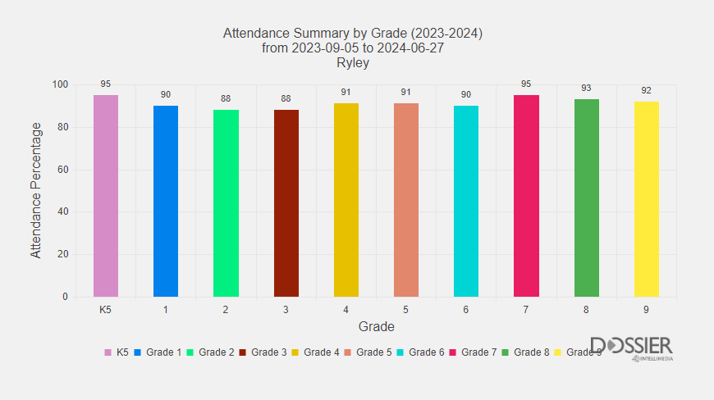

**Average Attendance for each month.**

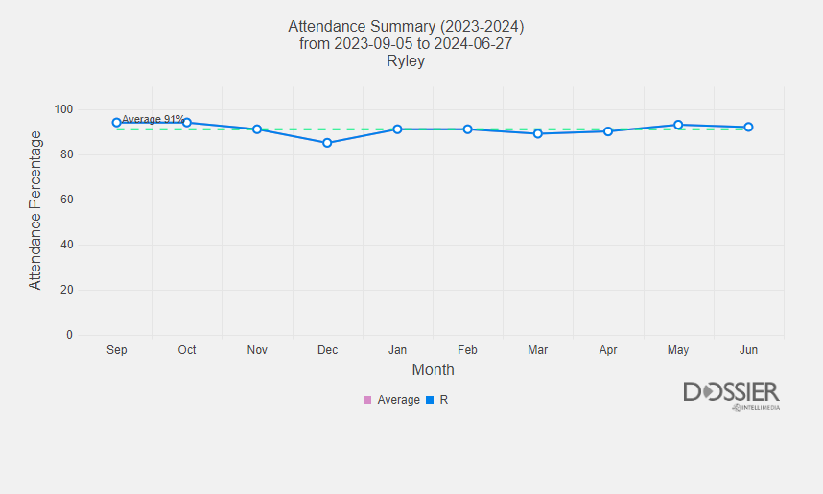

| **School Budget Summary 2023-2024** | | |
| --- | --- | --- |

| **Categories** | **Amount ($)** |
| --- | --- |
| Teachers | $,1035,927.11 |
| Support Staff | $284,345.14 |
| Substitutes | $30,533.17 |
| Classroom Resources | $9850.56 |
| General Resources | $16031.18 |
| Professional Development | $1858.41 |

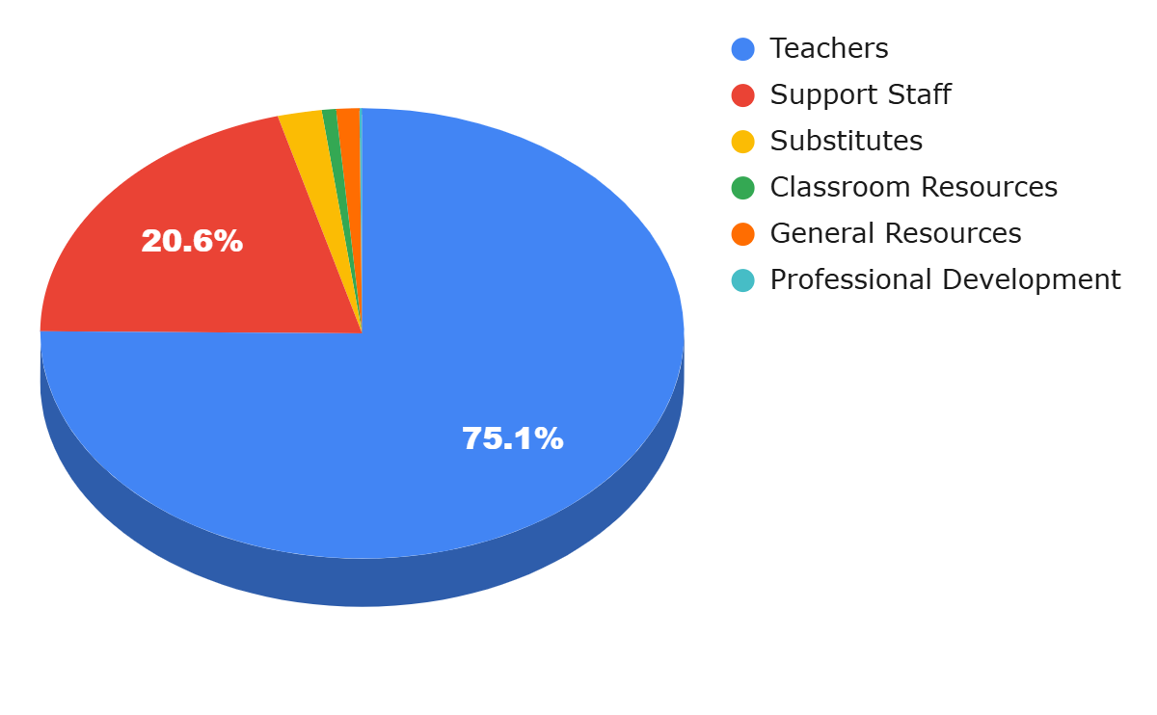

| **School Year Summary** |
| --- |
| The 2023-2024 budget prioritizes investments in our teaching and support staff, essential classroom resources, and professional development to ensure a high standard of education for all students. By thoughtfully allocating our resources, we continue to support the success, well-being, and engagement of our students, while providing a supportive and enriching environment for staff. This balanced approach ensures that Ryley School continues to exceed expectations at both the BRSD and provincial levels. |

| Stakeholder Engagement |
| --- |
| Our school hosts regular school council meetings to discuss school policies, initiatives, and improvement strategies.  * We offer parent/teacher/student led conferences in many different formats. * In addition to the school website and newsletter, we send weekly email reminders of upcoming school activities, achievements, and upcoming events to families. * We hold events such as open houses, celebrations, holiday concerts, and sporting events that invite the wider community to participate. * We work with the community to support local events. * We invite parents and guardians into the school to volunteer for numerous events such as: hot lunches, breakfast program, coaching, field trip supervisors, drivers, and classroom activities. * We collaborate with the Friends of Ryley School Society (FORSS) in support of the school. * We provide a neutral meeting space between families and support workers. * We collaborate with local emergency services for safety protocols and procedures. * We leverage rural settings to engage students in hands-on learning about agriculture, environmental stewardship, and outdoor skills. |

##### 

**EDUCATION PLAN 2024-2025**

## **Learning Success For All**

| **OUTCOMES**  Achieve learning outcomes and demonstrate growth through a focus on numeracy and literacy.  Engage and develop skills that enable students to adapt to and thrive in a rapidly changing society.  Recognize and support the diverse and unique learning needs of all students. | | | | | |
| --- | --- | --- | --- | --- | --- |
| **SCHOOL GOAL:**  Ryley School will enhance student achievement in both numeracy and literacy by focusing on personalized learning approaches, ensuring students acquire the essential skills needed to adapt and thrive in a rapidly changing society. We will recognize and support the diverse and unique learning needs of all students, ensuring equitable opportunities for growth. | | | | | |
| **Assurance Domains:**  **Student Growth and Achievement**: The ongoing progress of students’ learning, relative to identified provincial learning outcomes that enable them to engage intellectually, grow continuously as learners, and demonstrate citizenship.  **Local and Societal Context:** Engagement practices that enable the education system to proactively respond to the learning needs and diverse circumstances of all students. | | | | | |
| Strategies: Data-Driven instruction and targeted interventions, integrating real-world problem solving in numeracy and literacy, inclusive learning practices, strengthening foundational literacy and numeracy skills. | | | | | |
| Measures:   * Improvement in literacy and numeracy assessment scores across grade levels. * Growth in the number of students meeting or exceeding grade-level expectations in reading, writing, and math. * Positive feedback from students, parents, and teachers regarding the effectiveness of differentiated and personalized learning approaches. * Increased student confidence and engagement in problem-solving, critical thinking, and real-world applications of numeracy and literacy skills. | | | | | |
| Implementation Plan: Use formative and summative assessments to identify students' literacy and numeracy levels, implement targeted interventions for students needing additional support, incorporate project-based learning and cross-curricular activities that connect numeracy and literacy skills to real-world scenarios, fostering critical thinking, creativity, and adaptability, use differentiated instruction to meet the diverse needs of all learners, implement school-wide literacy and numeracy programs focused on early interventions, such as phonics and number sense in the early grades, while continuing to build on these foundations in the upper grades. | | | | | |
| Allocation of Resources:  DIBELS testing and mClass lessons, provide time for all teachers to plan and prepare for literacy intervention, CRM, Division 1 has been provided with magnetic whiteboards and alphabet tiles, Kindergarten provided with UFLI resources, EICS numeracy screener, Mathology | | | Professional Learning:  Provide ongoing professional development for teachers in the areas of differentiated instruction, numeracy and literacy interventions, and assessment for learning. Encourage collaboration among teachers to share best practices. | | |

## 

## 

## **Enhance High Quality Learning and Working Environments**

| **OUTCOMES** Prioritize resources to support student and system success.  Foster welcoming, caring and equitable learning and working environments.  Support and enhance the positive culture of teaching, leading and learning. | | | | | |
| --- | --- | --- | --- | --- | --- |
| **SCHOOL GOAL:**  Ryley School will prioritize the allocation of resources to create a welcoming, caring, respectful, and equitable learning and working environment. We will support and enhance a positive culture of teaching, leading, and learning, ensuring the success of all students and staff. | | | | | |
| **Assurance Domains:**  **Learning Supports:** Using resources to create optimal learning environments where diversity is embraced, a sense of belonging is emphasized and all students are welcomed, cared for, respected and safe.  **Teaching and Learning**: Teachers and leaders apply appropriate knowledge and abilities to make decisions that demonstrate professional practice standards, which result in quality teaching, leading, and optimum learning for all students  **Governance:** Processes that determine strategic direction, establish policy and manage fiscal resources. | | | | | |
| Strategies:  Equitable Resource Allocation, Enhancing Student Well-being and Mental Health Supports, Promoting a Positive School Culture and Climate, Support leadership opportunities for both students and staff, encouraging a culture of shared leadership. Establish student leadership programs, mentor teacher initiatives, and provide professional learning communities (PLCs) for staff development. | | | | | |
| Measures:   * Positive feedback from students, parents, and staff on school climate surveys regarding the school’s inclusivity, care, and overall environment. * Increased participation in school-wide initiatives focused on well-being, inclusivity, and positive behavior. * Higher staff retention and satisfaction due to professional development opportunities and leadership roles. * Increased student engagement and leadership participation across grade levels. * Improved academic performance and well-being among all students, especially those from diverse or vulnerable backgrounds. | | | | | |
| Implementation Plan: Ensure that financial and material resources are distributed equitably, prioritizing the needs of students requiring additional support, including those with diverse learning needs, English language learners, and students from low-income backgrounds, increase access to mental health and wellness programs by providing resources like student wellness facilitator (SWF), Mental Health Capacity Building (MHCB) programs, wellness workshops, and peer support initiatives. Create safe spaces for students to express concerns and seek help, continue building a positive school culture by promoting the values of respect, inclusivity, and kindness through school-wide initiatives such as character education programs, anti-bullying (Pink Shirt Day), and regular assemblies focused on positive behavior. | | | | | |
| Allocation of Resources:  Mental health and wellness support, professional development on inclusion, equity, and wellness, specialized support for diverse learners, classroom resources and materials, leadership and student voice, initiatives,technology and digital resources for equity, physical environment enhancements | | | Professional Learning:  Provide ongoing professional development on equity, inclusion, and cultural competency to ensure staff are equipped to meet the diverse needs of students. Focus on trauma-informed teaching practices, culturally responsive pedagogy, and restorative practices. | | |

## **Well Being**

| **OUTCOMES**  Prioritize and enhance well-being and positive mental health for all.  Promote inclusive environments that celebrate diversity and support all.  Students who self-identify as Indigenous are supported to achieve success. | | | | | |
| --- | --- | --- | --- | --- | --- |
| **SCHOOL GOAL:**  Ryley School will prioritize and enhance the well-being and positive mental health of all students and staff, promote inclusive environments that celebrate diversity, and ensure that students who self-identify as Indigenous are fully supported in achieving academic and personal success. | | | | | |
| **Assurance Domains:**   * **Learning Supports**- Using resources to create optimal learning environments where diversity is embraced, a sense of belonging is emphasized and all students are welcomed, cared for, respected and safe. * **Local and Societal Context**: Engagement practices that enable the education system to proactively respond to the learning needs and diverse circumstances of all students. | | | | | |
| Strategies: Creating Inclusive and Culturally Relevant Learning Environments, Dedicated Support for Indigenous Students, Promoting Mental Health Literacy and Resilience Skills | | | | | |
| Measures:   * Increased student and staff participation in mental health and wellness programs. * Positive feedback from students, families, and staff regarding inclusivity and support for Indigenous students. * Improvement in student mental health indicators and overall school climate as measured by surveys. * Higher academic achievement and engagement levels among Indigenous students. * Evidence of a more culturally responsive curriculum and teaching practices throughout the school. | | | | | |
| Implementation Plan: Implement school-wide mental health initiatives such as mindfulness practices, Incorporate culturally relevant pedagogy and materials into the curriculum that reflect the diverse backgrounds of all students, including Indigenous perspectives, Integrate mental health literacy programs into the curriculum, teaching students about mental health, coping strategies, and resilience. | | | | | |
| Allocation of Resources:  Resources for wellness materials (e.g., stress relief tools, informational brochures on mental health), funding for materials and resources that reflect diverse cultures in the curriculum, including books, guest speakers, and workshops, budget for Indigenous cultural programming, resources for implementing social-emotional learning (SEL) programs that promote well-being and resilience among students. | | | Professional Learning:  Provide training for staff on cultural competency, equity, and inclusive practices, focusing on understanding the unique needs of diverse students, particularly Indigenous students. | | |